**Task 1: Entity relationship diagrams**

# 1. What is an entity in the context of databases?

* It is a piece of information that corresponds to one or other related tables in the database. An entity is a category of object, person, event or thing of interest about which data needs to be recorded

# 2. The relationship between two entities may be one of three types, or degrees.

# What are the three degrees of relationship between entities?

# One to one

# One to many

Many to many

# 3. Draw entity relationship diagrams for each of the following pairs of related entities:

(a) Dentist and patients

(b) Students and teachers

Many

Many

(c) UK citizen and UK Passport

Many

Many

(d) Products and components

Many

Many

4. A company makes a range of kitchen utensils which they sell online. They record details of their customers, products and orders received in a database. An order may be for several products.

Complete the E-R diagram to show all the relationships between all the entities.

Customer

Product

Order

OrderLine

5. Complete the design of the order form shown below. Enter some data for a sample order for **three** different products.

|  |  |  |  |
| --- | --- | --- | --- |
| |  |  |  | | --- | --- | --- | | Mrs Juliet Munachi  15 Ludgate Hill  Manchester  M4 4AL |  | KitchenTools Ltd  10 Market Street  Manchester  M1 1PB  Order number:Z25467  Date:14/11/2022 | |
|  |
| |  |  |  |  |  |  | | --- | --- | --- | --- | --- | --- | | Line  1  3  5 | Qty  3  2  1 | Product code  GB9080  GB1012  GB3324 | Description  Cooking pots  Spoons  Dining Plates | Unit price  £15  £5  £7  **Total:£27** | Total price  £45  £10  £7 | |

On your order form, what are the primary key fields of the entities Customer, Product, Order, OrderLine?

* Customer: Customer ID
* Product: Product code
* Order: Order quantity
* OrderLine: Comapany ID

**Task 2**

This is a practical exercise using MS Access. You are going to be working with the database **RevisionSubs_stage1.accdb**. This consists of three tables called **bblCustomer, tblProduct, tblSubscription.**

Step 1: Add some records to the database

1. Load Access and find the database called **RevisionSubs_stage1.accdb**.
2. Open the database. Double-click the table **tblCustomer** and it will appear in **Datasheet View**. In this view, you can enter, delete or amend data.
3. Add the following record to the table **tblCustomer**

C444

Mr Basil Brown basil@brown.com

4. Add the following two records to **tblSubscription**

S1400 21/03/2016 20/06/2017 C444 P47

S1401 21/03/2016 20/06/2017 C444 P36

**Step 2: Designate primary key attribute in each table**

C:\Users\Pat\AppData\Roaming\PixelMetrics\CaptureWiz\Temp\9.jpg The **structure** of a table is defined when it is first created. These tables have been defined without primary keys, so the structure needs to be amended to define one or more fields in each table as a primary key.

5. Click **tblCustomer**. Click **View** at the left hand end of the toolbar underneath the main menu, and select **Design View**. C:\Users\Pat\AppData\Roaming\PixelMetrics\CaptureWiz\Temp\1.jpg

6. Click the **custID** field name. Now click the **Primary key** icon in the toolbar.   
A key symbol appears next to the field name.

I also did the same for the **tblProduct** and **tblSubscription** as shown below.

7. In **tblProduct**, make **productID** a key field.

8. In **tblSubscription**, make **subID** a key field.

9. Right-click the tabs for each table in turn, and choose **Close** each time. Answer **Yes** when asked if you wish to save the table.

**Step 3: Creating relationships between the tables**

C:\Users\Pat\AppData\Roaming\PixelMetrics\CaptureWiz\Temp\2.jpg We now need to create the one-to-many relationship between **tblCustomer** and **tblSubscription**, and the one-tp-many relationship between **tblSubscription** and **tblProduct**.

9. Click **Database Tools** in the main menu. Then double-click the **Relationships** icon in the toolbar.

10. A “Show table” window opens. Click each table in turn and click **Add**. Close the window and you will see the three tables displayed. Click and drag to put tblSubscription in the middle.

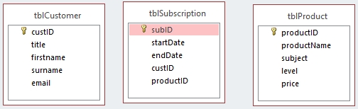

11. To create a relationship, you drag the primary key field from the “one” side to the corresponding field in the “many sides of the related table. Drag **CustID** from the **tblCustomer** table to **custID** in **tblSubscription**.

12 A window appears. Click the box next to **Enforce referential integrity**. This will ensure that you cannot create a record in **tblSubscription** for a customer who does not exist in **tblCustomer**. Now click **Create**.

If there is already data in tblSubscription which refers to a non-existent customer, you will see this message:

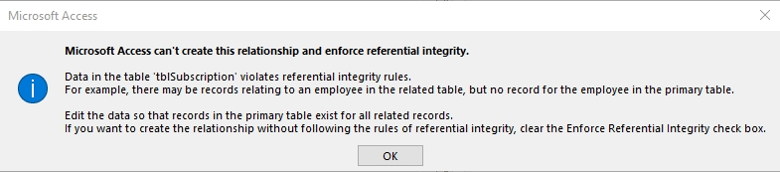

If you get this message, you need to take another look at the records in **tblCustomer** and **tblSubscription** and make sure you have all the necessary records on **tblCustomer**.

13. Create the relationship between **tblProduct** and **tblSubscription**. Remember to enforce referential integrity.

Now the relationships will be shown: I have shown this with the picture above after I’ve dragged them.

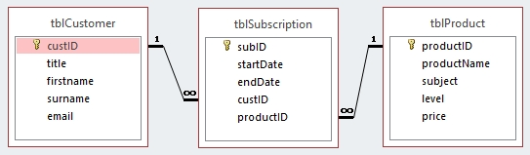

14. **Save** and close the database.